CSCE 1002

Fundamentals of Computing II

Final Project Report

 Report on Data Structures, Algorithms and Mythologies Utilized to Create Project

Instructor: Dr. Howaida Ismail

Spring 2023

Youssef Nader - 900226170

Haia Zayed - 900221674

Hana El Azzazi - 900222935

Department of Computer Science and Engineering

Start Up Plan:

Primarily, we decided to explore the algorithms, Brute Force and Rabin Karp. Meaning the way they functioned, their advantages as well as disadvantages. This can be seen through this google document we had created that listed the functionalities as well as pros and cons regarding each algorithm presented to us by the department. Additionally, we were keen to observe the complexities of each algorithm to determine which would be the most efficient.

QT Screenshots:

Home Page.

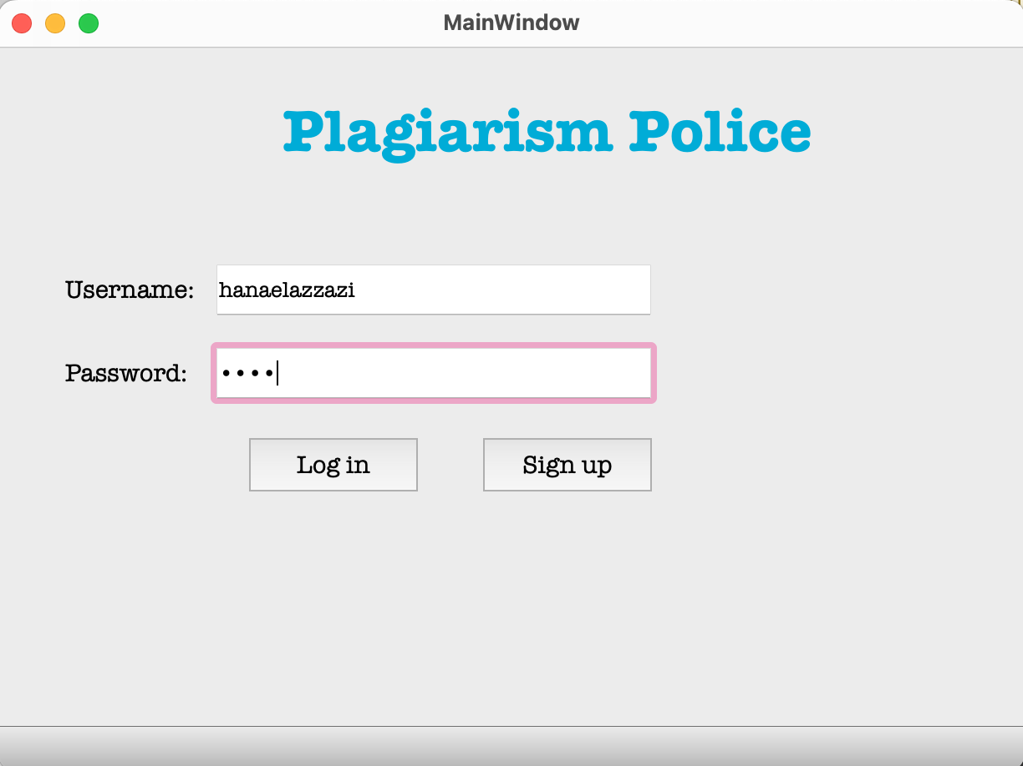

Sign Up Page.

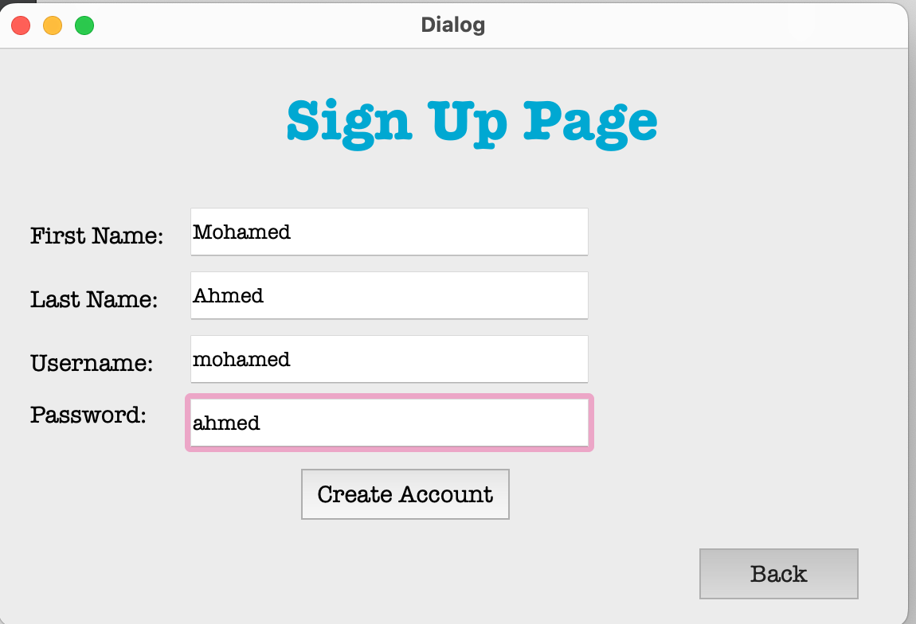

The user’s information is added to the database as you can see in 10.

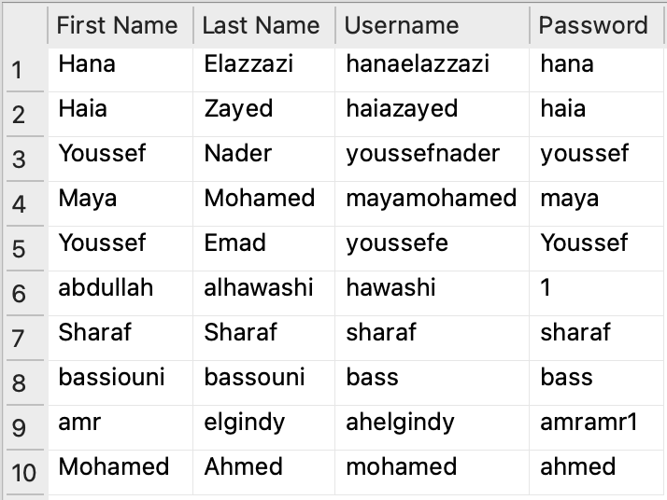

The user chooses whether they want to check plagiarism between two codes or check plagiarism for writing.

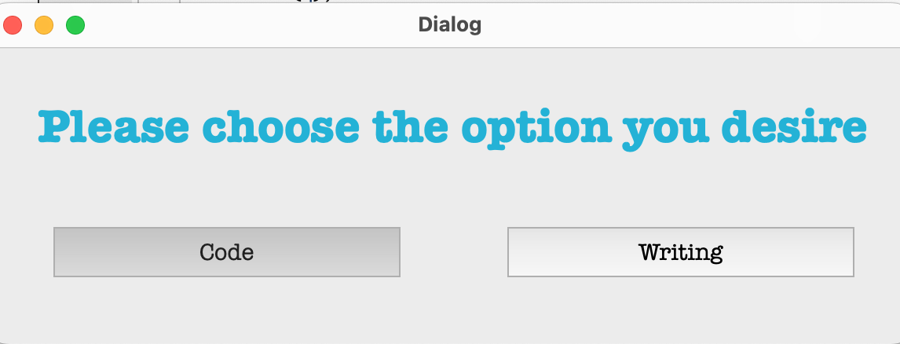

If code is chosen

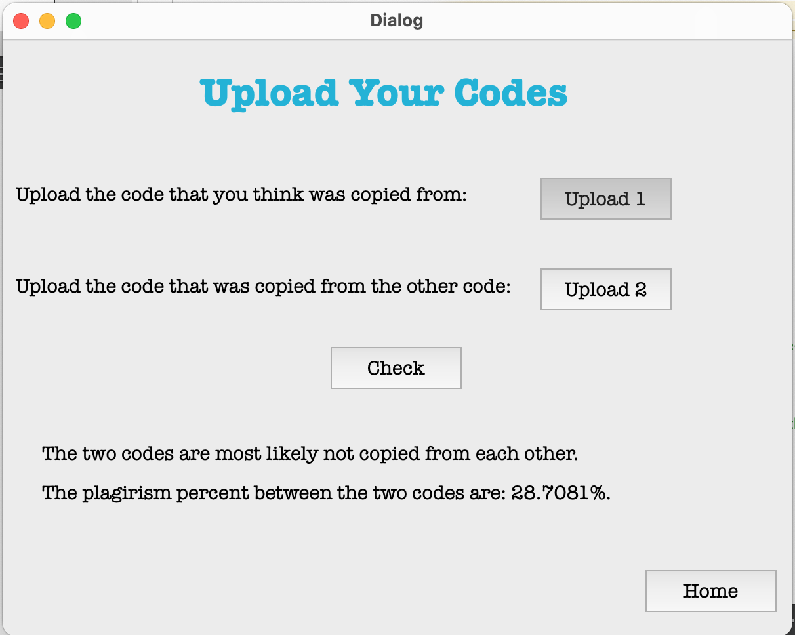

Returning back to Home, if writing is chosen the user uploads the desired writing then chooses the type of detection they desire.

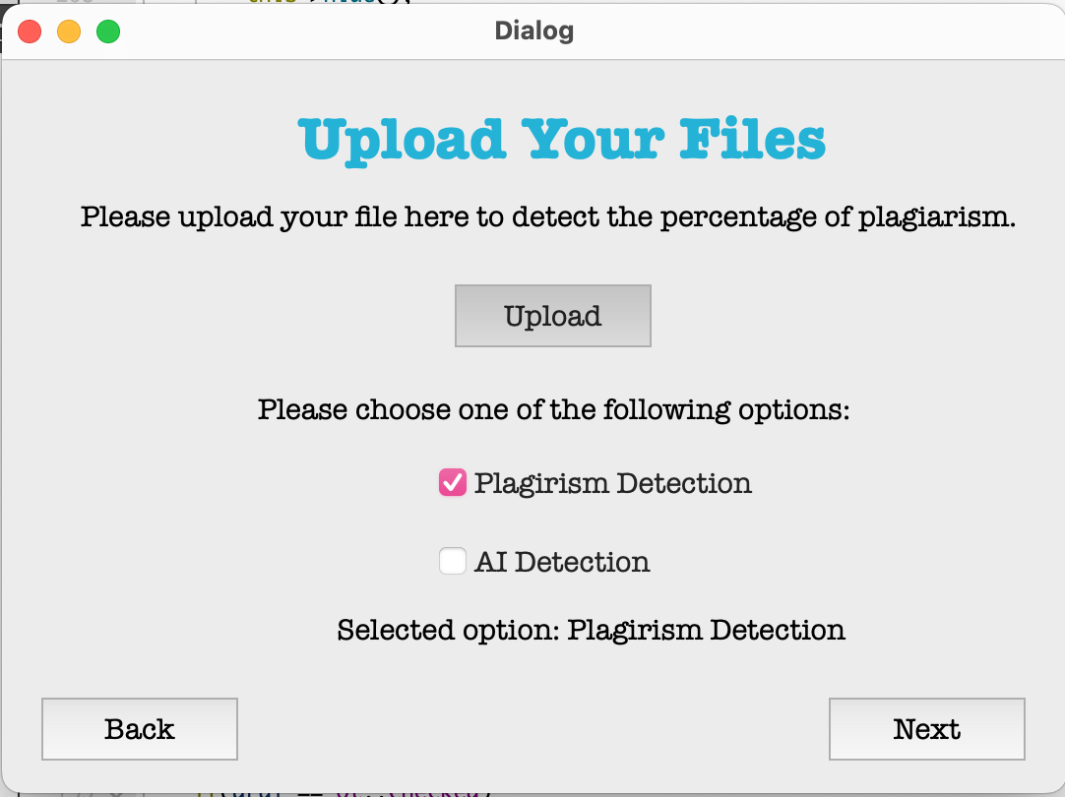

If user chose Plagirism Detection

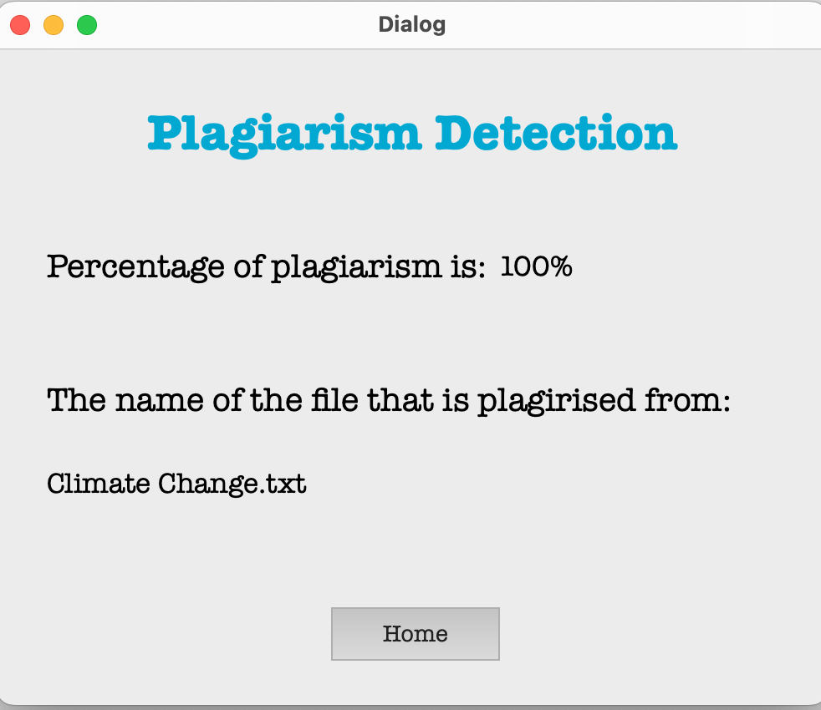

The file climate change that was just uploaded was added to the database line 5.

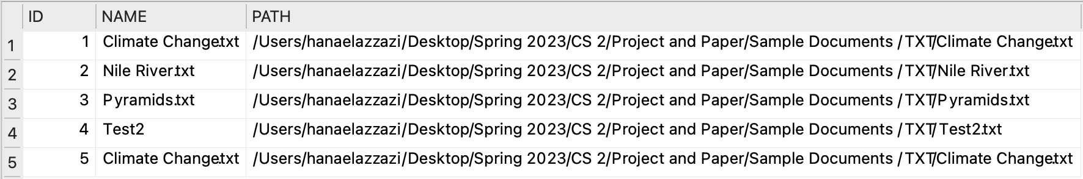

Returning back to Upload Your Files and the user chose AI Detection

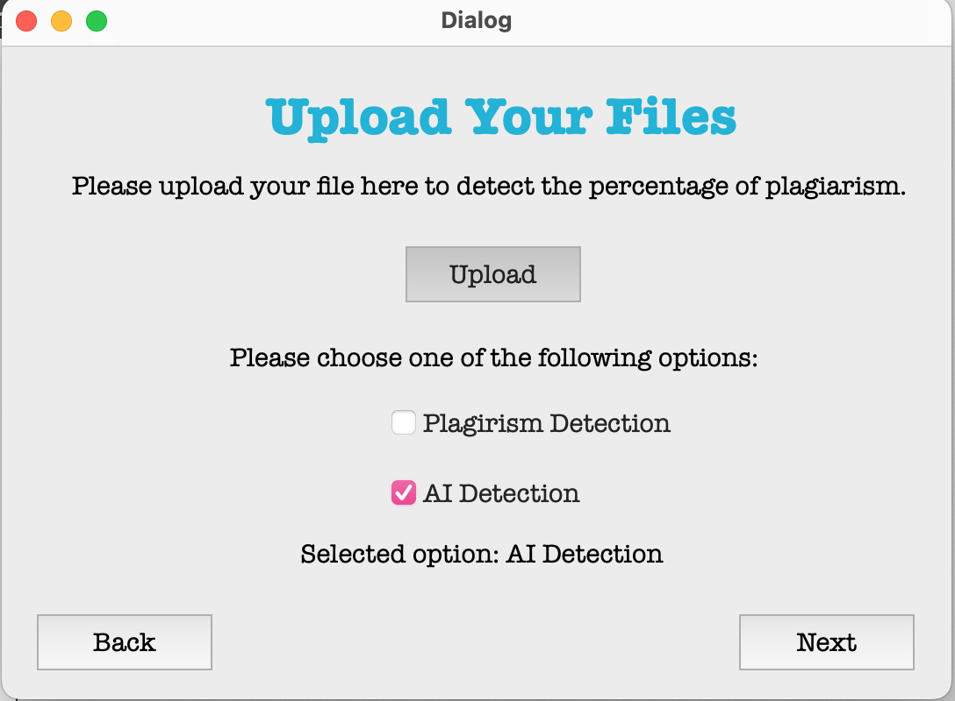

This would be the output

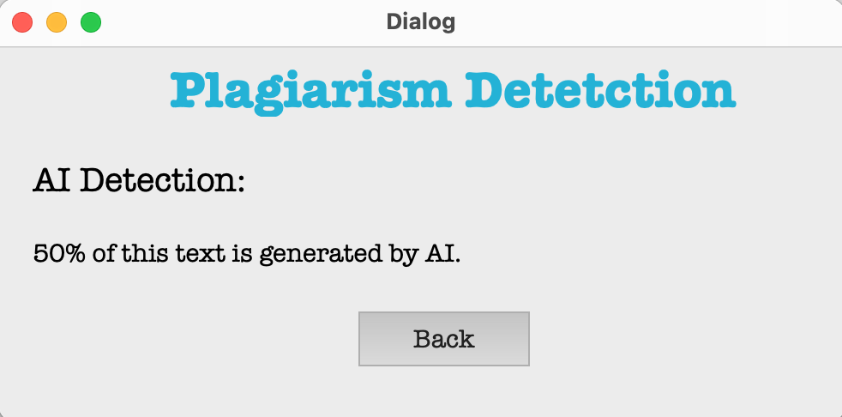

XCode Screenshots:

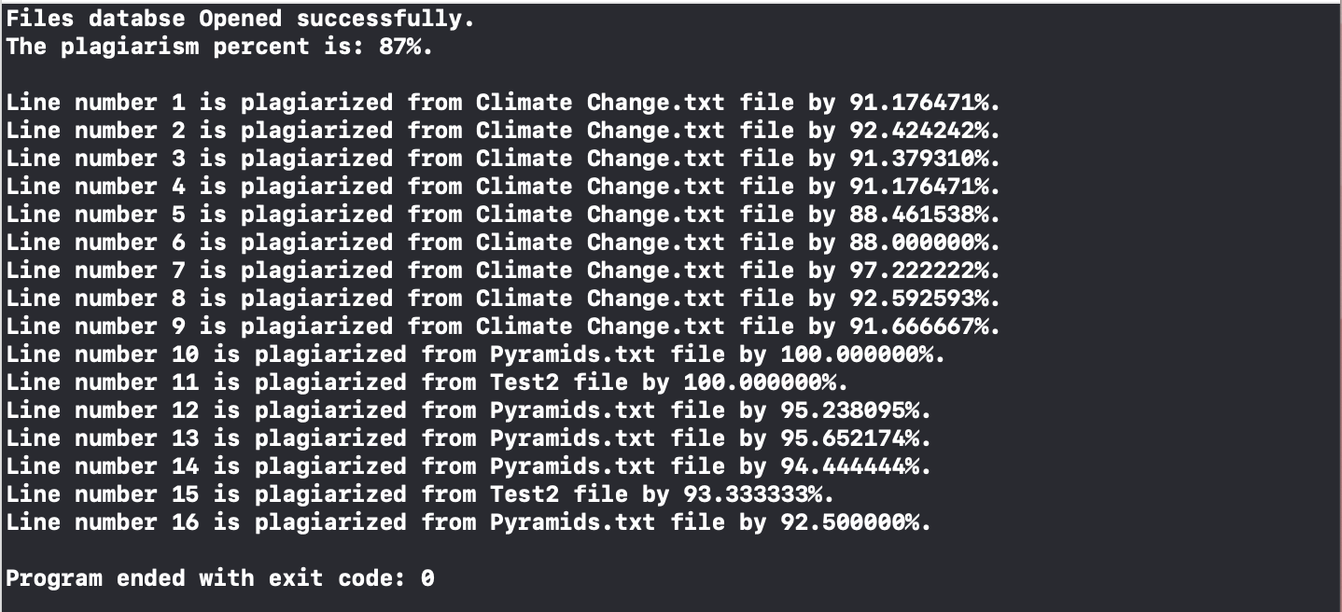

The files we uploaded to GitHub:

1. XCode Files
2. QT Files
3. Python Files (sharaf.py, sharaf2.py)
4. Two Databases (p.db, signup.db)
5. dumb.txt (where results appear and we read the results from into code)